North Somerset Planning Application 18/P/5118/OUT
Chew Magna Parish Council Objection to Bristol Airport’s Appeal for further expansion based on the addendum to the Environmental Statement and further the new associated documents provided to Bristol Airport Planning

Chew Magna Parish Council (CMPC) strongly OBJECTED to Bristol Airport’s original planning application for expansion and confirms this objection. CMPC also strongly objects to the Airport’s Appeal. The reasons outlined below include comments on the Airport’s Environmental statement and Appeal associated documents.

- Climate Emergency:
Chew Magna Parish Council like BANES, Bristol and North Somerset and have declared a Climate Emergency as it is increasingly clear of the negative impact carbon consumption is having on our planet. In spite of Bristol Airport’s commitment to be carbon neutral by 2025, these plans do not include emissions from the planes themselves or vehicles travelling to and from the airport. The graph below shows the impact of the airport if North Somerset Council (yellow) were able to achieve zero emissions by 2030 and if Bristol Airport (blue) were capped to 10m passengers per year. Bristol Airport would still be responsible for 2 million tonnes of carbon per year. The red area show further avoidable emissions if the airport was capped at 10 m passengers per year.

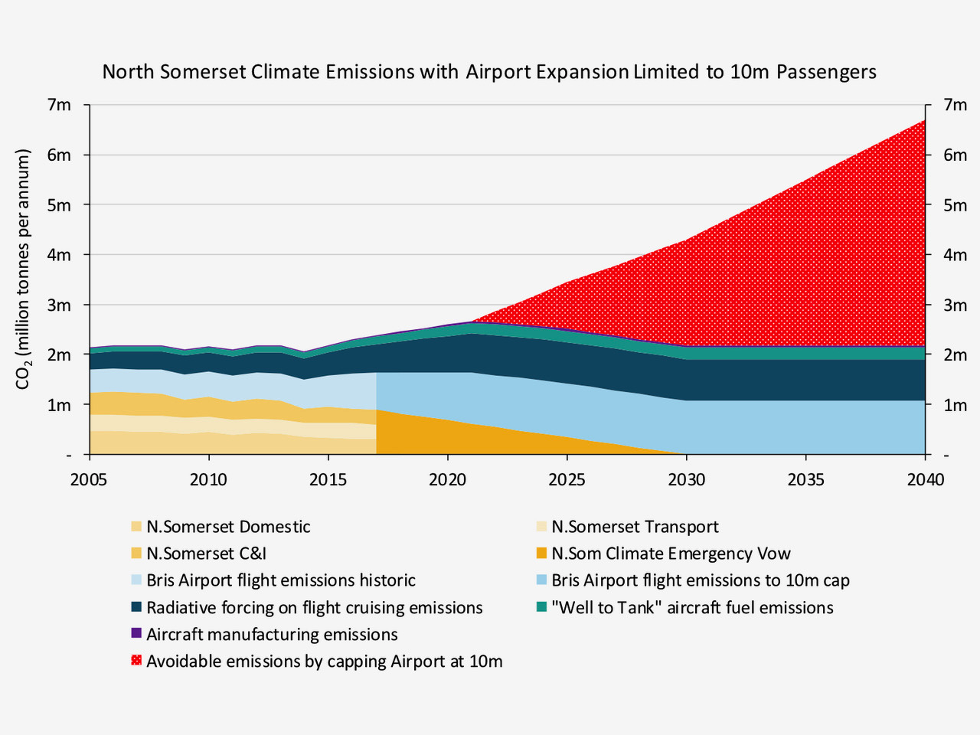

In the Airport’s Appeal it still sees the growth in emissions as being insignificant.
- The Airport is still using a 'planning assumption' of 37.5MtCO2 for gaining consent rather than the lower figure of 30MtCO2 which is based on the Net Zero Emissions target and the Committee of Climate Change Report. CMPC believe that the lower figure should be used.
- There is no assessment of non-CO2 climate impacts like air contrails on the basis of “scientific uncertainty” and CMPC believes that an assessment should be made of the non-CO2 climate impacts.
- The Committee of Climate Change on 8 December 2020 updated its position on aviation as part of the Sixth Carbon Budget indicating that aviation should not be allowed to grow. In light of this report, Bristol Airport should update the aviation emissions section. The slower growth case falls into the Sixth Carbon Budget which commences 2033.

The Appeal documents maintain that air quality would remain within limits set by Government, but air quality would clearly be reduced.

2 Traffic Congestion and Inadequate Transport links:
Bristol has the 9th largest airport in the country. All the other 8 UK airports are served by either a motorway, a dual carriageway and/or a rail link. Bristol Airport is served by a single carriageway road (A38) that connects with the M5 to the South after 18 miles, and to the North via the A4 to the M5 (13 miles away). The table below illustrates the transport links to the top 10 airports in the UK.

Top 10 UK Airports and their transport links.

1 | Heathrow | M4, M25, rail link
2 | Gatwick | M23, rail link
3 | Manchester | M56, rail link, Metrolink
4 | Stansted | M11, A120 (dual carriageway), rail link
5 | Luton | M1, rail link
6 | Edinburgh | M9, M90, A90 (dual carriageway), Tram link
7 | Birmingham | M42, A45 (dual carriageway), rail link
8 | Glasgow | M8, A737 (dual carriageway)
9 | Bristol | A38 (single carriageway)
10 | Belfast | M2

In the original application and the Appeal, no consideration is given to the connections to the East of the airport which are via minor B roads that pass-through Chew Magna. These country roads (particularly along the B3130) narrow down to a single lane in a number of places including at the entrance, middle and exit to the village. The congestion caused by the volume of traffic is evident on a daily basis. Common sense would dictate that no expansion approval should even be considered until substantial improvement to the road infrastructure is in place, rather than vague promises of future development (which have been regularly discussed for the past 20+ years).

In the Appeal documents, the Airport predicts very little improvement in public transport which was 13.8% in 2019 with a target of only a target of 17.5% for 12 mppa. This in turn means that most of the passengers will be traveling to the airport by car as evidenced by the Airport continuing to seek the removal of the seasonal restriction on the existing Silver Zone Car Park Phase 1 to allow for year-round use. In addition, they continue to request an extension to the Silver Zone Car Park Phase 2 to provide approximately 2,700 additional spaces which is predicted to be open in 2025, just after growth to 10 mppa (predicted in 2024).

To prevent further ingress into the Green Belt it is important that the airport honour the condition under the planning consent of 2011 that the Multi Storey Car Park 2 is to be constructed for 10mppa (predicted in 2024) but this has not been built.

The Airport then suggests in the Appeal documents that Multi Storey Car Park 3 should be conditional on achieving 16% public transport use which is a very challenging target particularly in light of the Airport’s low-cost parking strategy on green belt land (a major revenue generator for them) and because the pandemic has reduced people’s use of public transport.

If the airport were allowed to grow to 12 mppa there will be a major increase of car travel. This will be in addition to growth in other car travel on the A38 and A370 due to new housing evelopments. The pandemic has also meant that fewer people will travel by public transport and there may be a considerable time gap before public transport numbers rise back to levels seen in 2017.

3 Noise:
If the Airport were allowed to increase to 12mppa (predicted in 2030), there would be a significant increase in number of air transport movements from 61,382 in 2019 to around 75,500 annual commercial movements. In addition, the Airport predicts a continuing level of 10,000 ‘positioning’ and ‘other’ movements. ‘Other’ movements include private jet movements and the flying club. ‘Positioning’ flights are usually empty aircraft re-positioning themselves from one airport to another. In total therefore there would be an increase to 86,500 aircraft movements each year, an increase of 19.5%.

Currently aircraft are required to adhere to a straight-line flight envelope of 5 miles on take-off and landing. To manage this increased capacity, the airport is looking to change the 5-mile restriction and peel off earlier. This will greatly increase the number of houses and people the planes will be flying over and disturbing.

The airport wishes to significantly increase the number of night flights in the summer months by amalgamating those which it does not use in the winter months. CMPC strongly objects to this.

Shoulder Air Transport Movements between 23.00 - 23.30 and 06.00 – 07.00 hrs were set under a condition of the planning consent of 2011 to grow to 10 mppa. There was to be a limit of 10,500 per year. Bristol Airport has now offered to reduce this to 9,500 per year. As the Operations Monitoring Report for 2019 shows there were 8,371 aircraft movements, it is disingenuous for the Airport to say that they have reduced the number of these flights when those movements have never occurred.

4 Health:
Traffic congestion and more aircraft journeys bring with it a hidden killer in the form of damaging emissions. Various medical studies have drawn the link between serious illness and transport emissions. Increasing the concentration of these around the airport will potentially have a damaging impact on residents’ health and wellbeing. Carbon emissions from aircraft and the height at which they are emitted also exaggerate the impact of carbon on air quality and therefore health.

5 Increased flooding risk:
Due to the poor transport links and no rail link then for the airport to increase its capacity further more Green Belt would be covered by car parking as indicated in point 1 above and the impervious surfaces would cause more run off. In addition, there would be less ground to soak up heavy rainfall. Both of these factors would in turn increase the likelihood of flooding in Chew Magna. There could also be an increased risk of contamination by water sewage.

6 Inaccurate information in the application provided by Bristol Airport:
A study in 2019 carried out for Campaign to Protect Rural England by the independent New Economics Foundation casts major doubt on the potential economic benefits claimed for the proposed expansion of Bristol Airport. The NEF study concludes that:

- The proposed development of the airport is incompatible with inevitable and essential future constraints on air travel because of climate change.
- Claimed benefits for the West of England region have been overstated by almost 50%.
- Claimed benefits for the wider South-West region and Wales have been overstated by as much as 70 %.
- Much of the methodology used by the Airport’s advisers appears to be inconsistent with the methods recommended and used nationally.
- Using Dept for Transport standard models, traffic at Bristol Airport in 2030 is likely to be only 8.5 million passengers a year, not the 12 million suggested by Bristol Airport Ltd.
- Most of the additional traffic will come from “displaced” activity from other airports that already have spare capacity.

The full report can be found on the NEF website at:
https://www.nefconsulting.com/cpre-expansion-of-bristol-airport and on the CPRE Avonside website at:http://avonside.cprelocalgroups.org.uk

